

Digital Literacy
Reg No.25BEC10040
Name: Ashesh Kumar Baidya
Project Report
Task 1
I used Canva to design my infographic because it offers free templates and easy drag-and-drop features. My design highlights three important aspects of digital skills for students: digital literacy, useful tools, and safe internet practices. The top section defines digital literacy as the ability to find, evaluate, create, and communicate information using digital technologies, supported by critical thinking and research skills. The right section introduces tools like Google Drive, Canva, Notion, and Zoom that enhance productivity and collaboration. The bottom section emphasizes safe internet practices such as using strong passwords, adjusting privacy settings, and avoiding scams.
One interesting part of the process was experimenting with icons and layouts to make the information visually appealing. I found it slightly difficult to balance text and visuals so that the slide was informative but not overcrowded. Overall, the design helped me understand how digital literacy connects with practical tools and online safety, and how visual communication can make these ideas clearer.
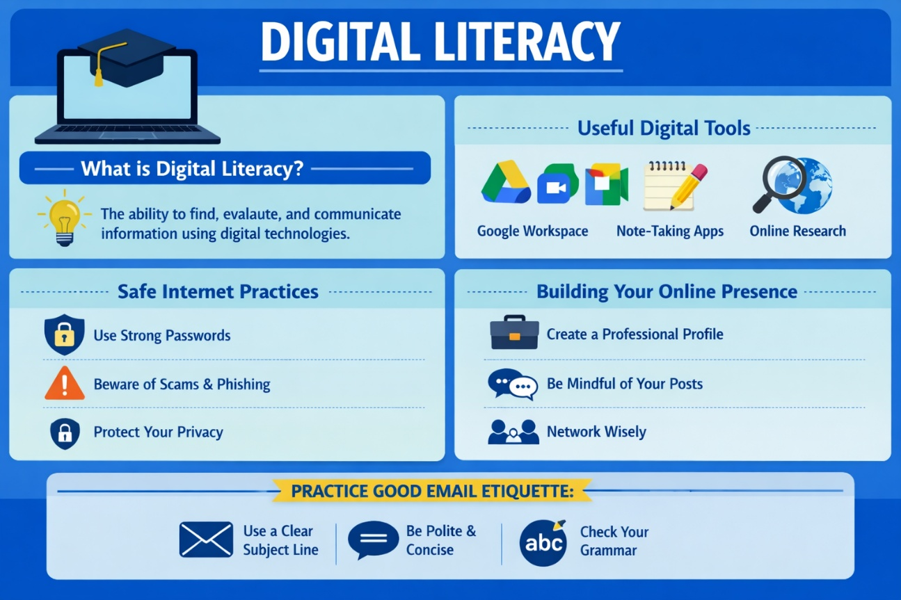

Task 2
On GitHub, I set up a profile README that includes my name, branch, year, and a short statement about what I hope to learn. GitHub is primarily used for version control and showcasing coding projects, so I plan to use it to document my coursework, coding challenges, and collaborative projects over the next four years.
On LinkedIn, I updated my Education section with my current degree, institution, and expected graduation year. LinkedIn is a professional networking platform, and I intend to use it to connect with peers, professors, and industry professionals, while also sharing achievements and seeking internship opportunities.
On Kaggle, I created a profile to participate in data science competitions and access datasets. Over the next four years, I aim to use Kaggle to strengthen my machine learning skills, collaborate on projects, and build a competitive portfolio.
This combination of platforms will help me grow academically, professionally, and technically.
Following are the screenshots of my profiles.
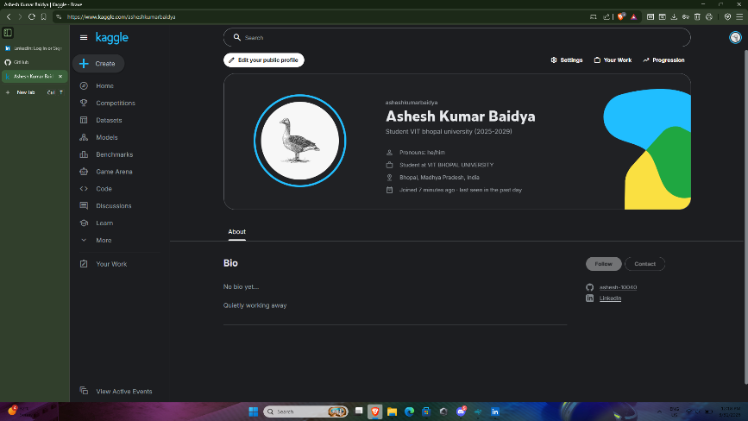
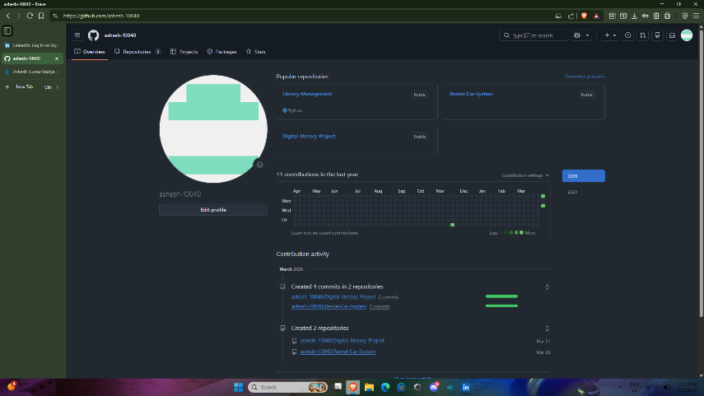

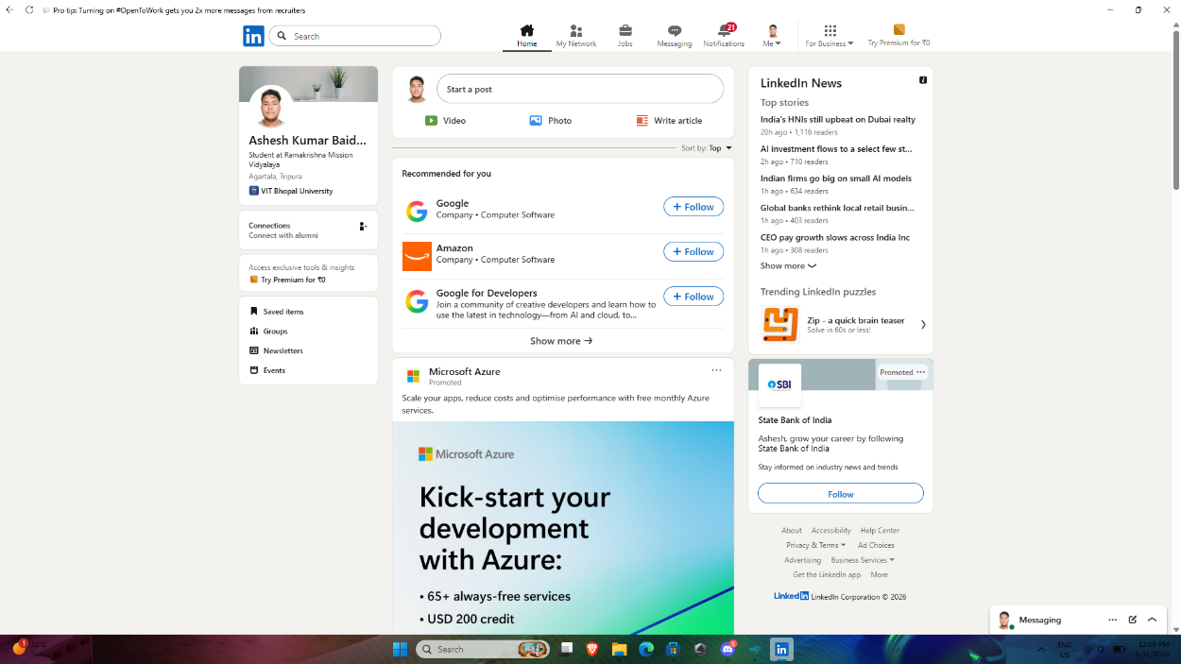

Task 3
For this task, I used two platforms: HackerRank (for coding practice) and Google Workspace (for collaboration). On HackerRank, I created an account and completed the beginner-level challenge “Solve Me First,” which helped me strengthen my Python basics and gain confidence in problem-solving. The platform provided instant feedback and a score, motivating me to continue exploring more challenges.
In the collaboration part, I designed a Google Form titled Digital Literacy Awareness Quiz with five questions, including multiple choice and short answer formats. The form was linked to a Google Sheet to automatically collect and organize responses. This exercise taught me how digital tools can be used to create interactive assessments and manage data efficiently.
These platforms will help me academically by improving my coding skills, enhancing my logical thinking, and enabling me to collaborate effectively with peers. HackerRank builds technical competence, while Google Workspace supports teamwork, surveys, and structured data collection. Together, they prepare me for both academic projects and professional environments where digital literacy and coding are essential.

Part A

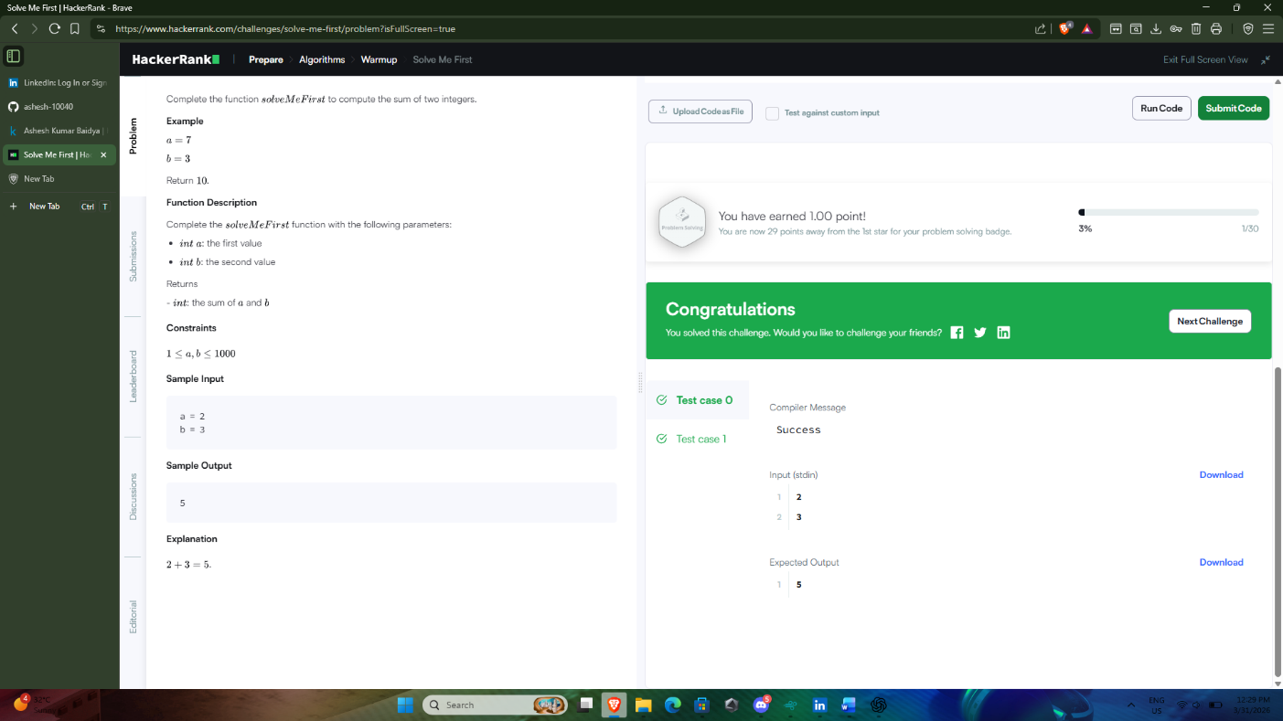

Part B

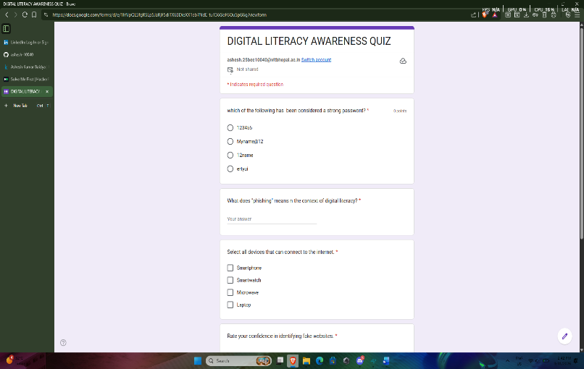

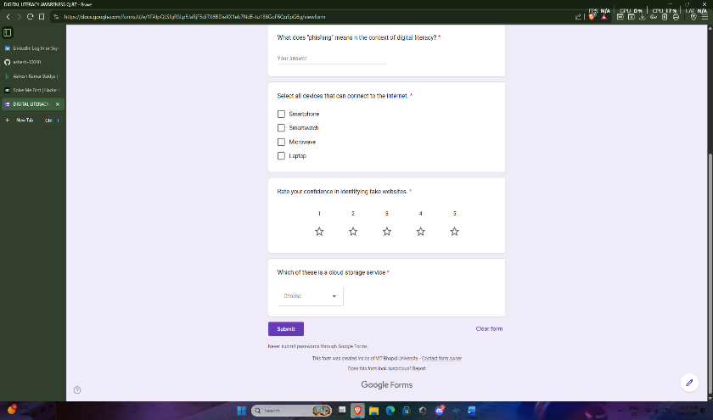

Link of google form:
https://forms.gle/18Ad5qdeYjccVp5A8

Task 4
Part A
Email 1
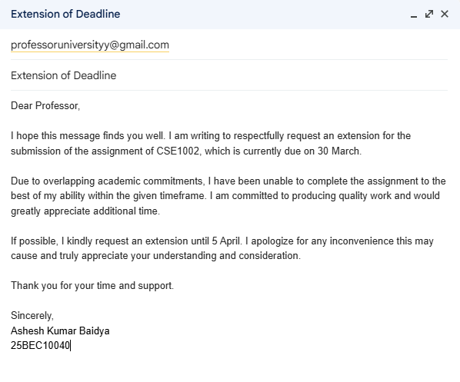

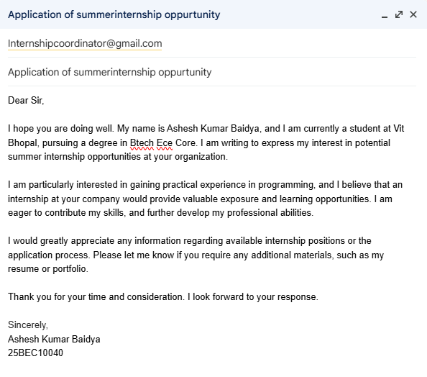
Email 2

Part B
Responsible Social Media Use for College Students
Do’s:
- Think before posting; ensure content is respectful and professional.
- Use privacy settings to control who can view your posts.
- Share academic achievements and professional updates to build your digital presence.
- Verify information before reposting to avoid spreading misinformation.
- Engage positively with peers, professors, and professional networks.
Don’ts:
- Post offensive, discriminatory, or inappropriate content.
- Overshare personal details that could compromise safety.
- Engage in online arguments or cyberbullying.
- Share confidential academic or workplace information.
- Rely solely on social media for networking; balance with in-person connections.

Poor digital communication can have serious consequences. For example, a college student once posted negative comments about their internship company on social media, assuming only friends would see it. However, the post was shared widely and reached the company’s HR department. As a result, the student lost the internship offer and damaged their professional reputation. This situation highlights the importance of maintaining professionalism online. The student could have handled frustrations privately, either by discussing concerns with a supervisor or seeking advice from a mentor. By exercising discretion and using respectful communication channels, the issue could have been resolved constructively without harming future career opportunities.

Task 5
Part A
Case Study: Phishing Attack on a College Student
Phishing is a cybercrime in which attackers impersonate trusted organizations to trick victims into revealing sensitive information such as login credentials, UPI PINs, or banking details. It relies on social engineering and psychological manipulation rather than technical hacking.
How it happens (step-by-step):
- The attacker crafts a convincing email or SMS, often imitating a bank, payment app, or even a university portal.
- The message uses urgency or fear — for example: “Your UPI account will be suspended unless you verify immediately.”
- A malicious link redirects the victim to a fake website that looks identical to the legitimate one.
- The victim enters their username, password, or UPI PIN, believing they are securing their account.
- The attacker instantly captures these details and uses them to transfer money, access accounts, or steal identity information.
Targeted individuals:
Students and young professionals are particularly vulnerable. They frequently use online portals and UPI apps, often multitask while studying or working, and may overlook small signs of fraud.
Consequences:
Victims face direct financial loss, compromised accounts, and emotional stress. In one real incident reported in The Hindu (2023), a Bengaluru student lost ₹45,000 after entering details on a fake UPI page. Beyond monetary damage, phishing can lead to identity theft, misuse of personal data, and long-term reputational harm. For students, this can mean losing trust in digital platforms, difficulty recovering stolen funds, and anxiety about future online transactions.
Phishing demonstrates how cybercriminals exploit human psychology more than technology, making awareness and vigilance the most effective defence.

Part B
Prevention Checklist
Stay Safe Online Checklist (for College Students in India)
- Verify links before clicking – hover over URLs to check authenticity.
- Never share OTPs or UPI PINs – banks and apps never ask for them.
- Enable two-factor authentication on email, social media, and banking apps.
- Use strong, unique passwords for each account.
- Check sender details – avoid responding to suspicious emails or SMS.
- Update apps and OS regularly to patch security vulnerabilities.
- For UPI safety: Always confirm the recipient’s name before approving payments.
- For UPI safety: Disable auto-approval features; manually authorize every transaction.
- Report incidents immediately via the National Cyber Crime Portal (cybercrime.gov.in) or Helpline 1930.

While researching cybercrime, I was most surprised by how sophisticated and convincing phishing attacks have become. I had assumed that fraudulent messages would be easy to spot, full of spelling mistakes or poorly designed websites. Instead, I discovered that many phishing pages are nearly identical to genuine portals, sometimes even using secure-looking URLs and logos. This blurred line between real and fake made me realize how vulnerable everyday users, especially students, can be when they are in a hurry or distracted.
Another surprising aspect was the scale of financial losses reported in India, particularly through UPI fraud. Even small mistakes, like entering a PIN on a fake app or approving a request without checking the recipient, can result in thousands of rupees being stolen instantly.
As a result of this research, one habit I will personally change is slowing down before clicking links or authorizing payments. I will carefully verify URLs, double-check UPI requests, and avoid rushing through online transactions. This small but consistent practice can protect me from falling victim to cybercrime and help me build safer digital habits.

